**CDAC Mumbai PG-DAC AUGUST 24**

**Assignment No- 2**

1)Write a program that checks if a given year is a leap year or not using both if-else and switch-case.

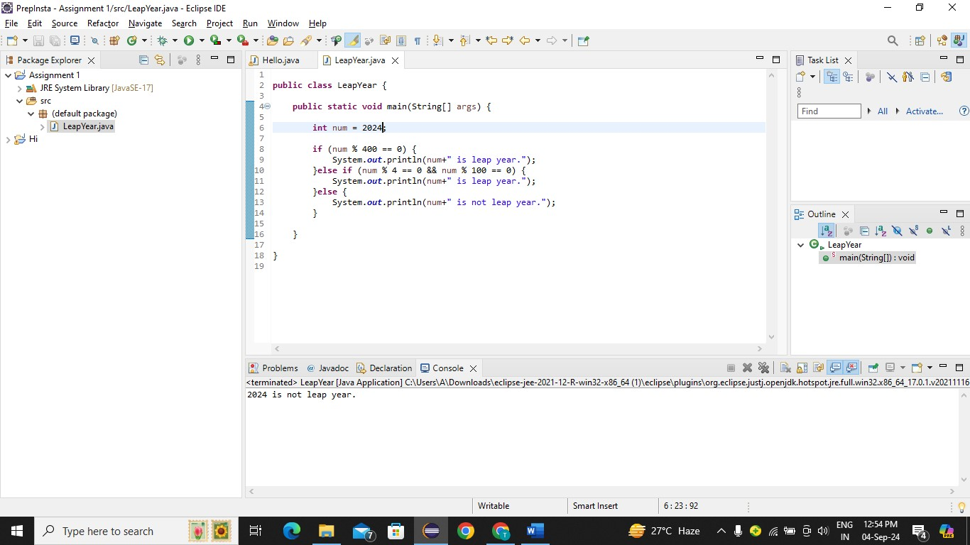

2)Implement a program that calculates the Body Mass Index (BMI) based on height and weight input using if-else to classify the BMI int categories (underweight, normal weight, overweight,etc).

Sol :-

BMI stands for body mass index. It’s a fat in a body.

Formula –

BMI = weight(kg) / [Height(m^)]^2

Note - Here mass is in, kg and height is in, m.

To convert height in m from inches we take its square.

Categories based on BMI

Underweight - < 18.5

Normal weight :- 18.5 =< BMI= < 24.9

Overweight :- 25 - 29.9

Input : Height,

Weight

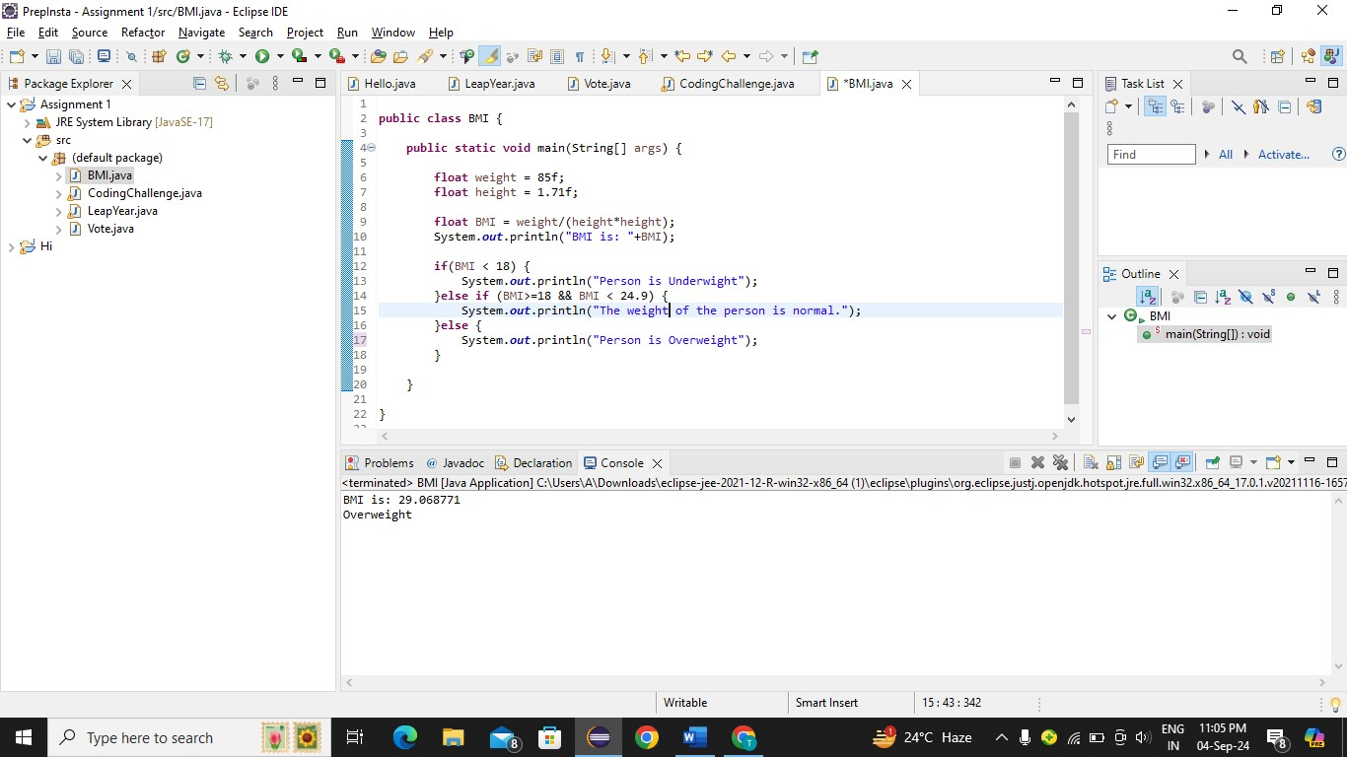

3)Write a program that checks if a person is eligible to vote based on their age.

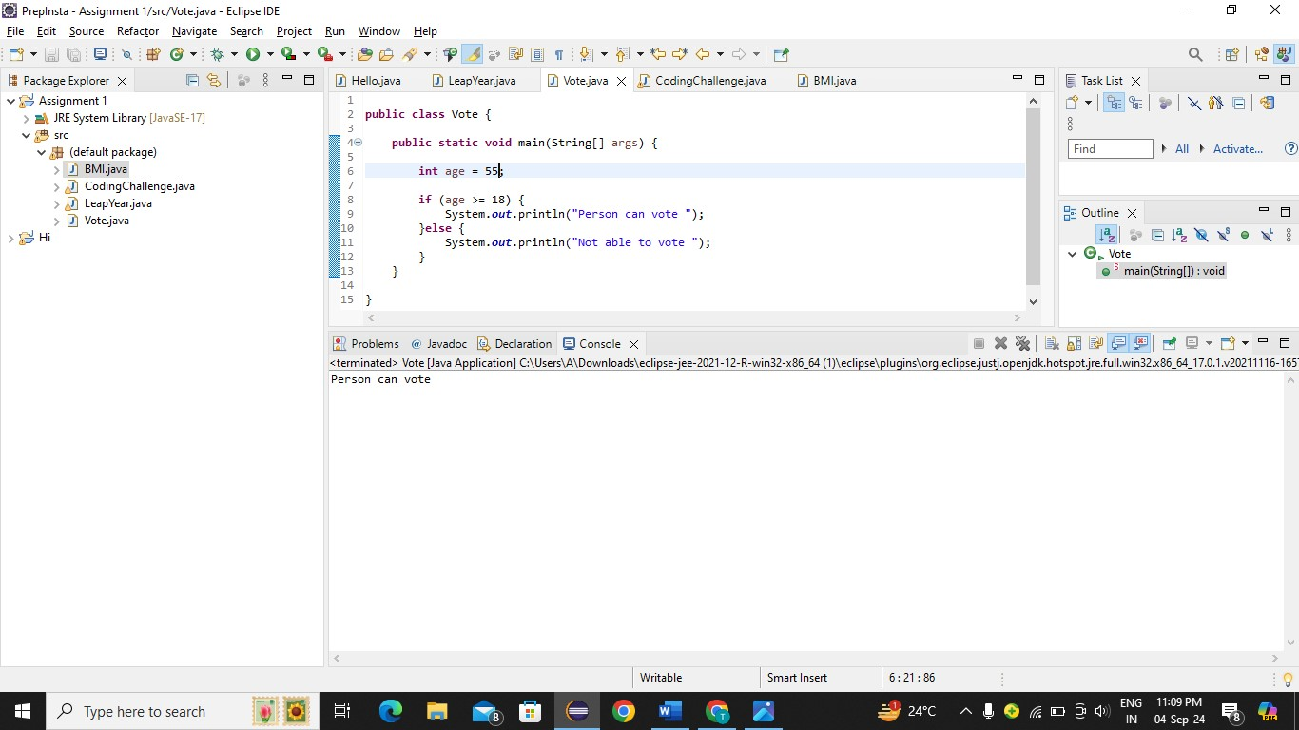

4)Write a program that takes a month (1-12) and prints the corresponding season (Winter, Spring, Summer, Autumn) using a switch case

Pseudo code:

Int month

String Season

Switch (month){

Case 12:

case 1:

case 2:

Season = “Winter”

BREAK

Case 3:

case 4:

case5

Season = “Spring”

BREAK

Case 6:

Case 7:

Case 8:

Season = “summer”

Break

Case 9:

Case 10:

Case 11:

Season = “Autumn”

Default :

Season = “Invalid Month”

break

}

SOP(Season)

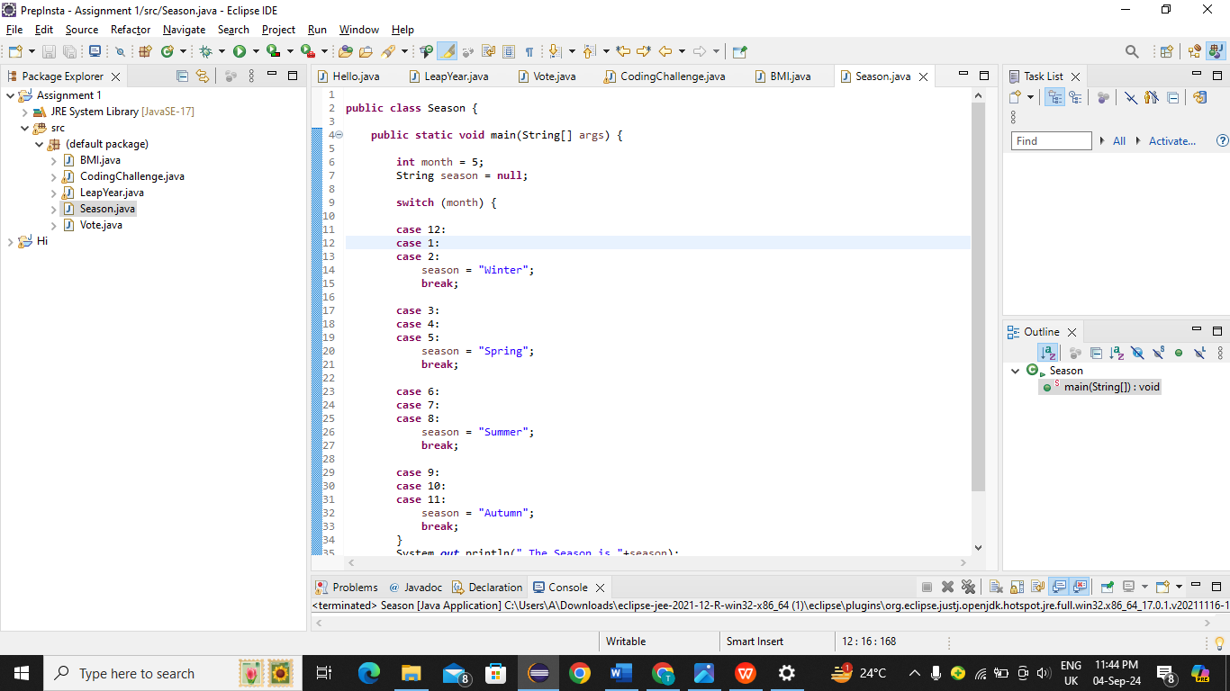

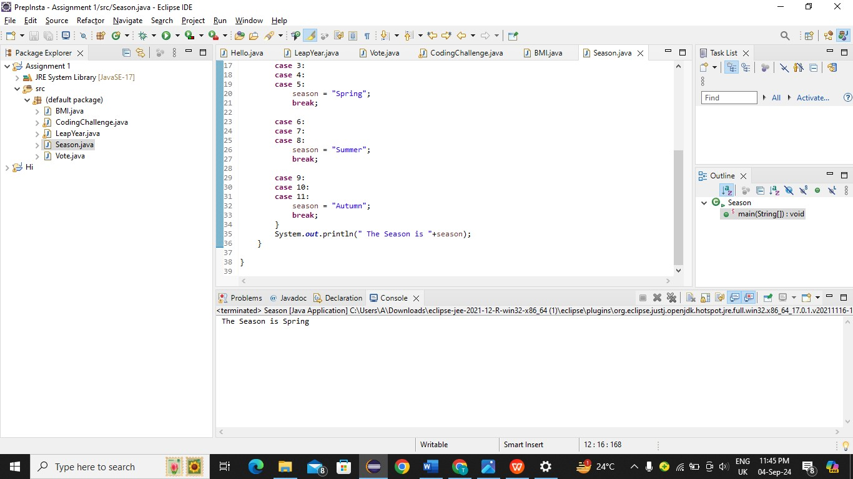

5)Write a program that allows the user to select a shape (Circle, Square, Rectangle, Triangle) and then calculates the area based on user-provided dimensions using a switch case.

Soln 🡪

Psudo code

SOP(“Select the shape: ”)

Scanner scanner = new Scanner(System.in)

SOP(“Select 1 for Circle: ”)

SOP(“Select 2 for Square: ”)

SOP(“Select 3 for Rectangle: ”)

SOP(“Select 4 for Triangle: ”)

Int shape = Scanner.nextInt()

Switch (shape){

Case 1:

Area = Circle formula

Case 2:

Area = Square formula

Case 3:

Area = Rectangle formula

Case 4:

Area = Triangle formula

Default:

Area =“Wrong shape Enter”

}

SOP(The areak of is”+);